**PIZZA SALES SQL QUERIES**

 PIZZA SALES SQL QUERIES 

**KPI’s (Key Performance Indicators) :**

1. Total Revenue (Sum of Total Price)

***INPUT***

SELECT sum(TOTAL_PRICE) AS TOTAL_REVENUE FROM `dominos pizza sales`;

***OUTPUT***

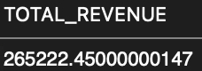

1. Average Order Value (Revenue/Sum of orders)

***INPUT***

SELECT * FROM `dominos pizza sales`;

SELECT COUNT(DISTINCT ORDER_ID) AS TOTAL_NUMBER_OF_ORDERS

FROM `dominos pizza sales`;

SELECT SUM(TOTAL_PRICE)/COUNT(DISTINCT ORDER_ID) AS AVERAGE_ORDER_VALUE FROM `dominos pizza sales`;

***OUTPUT***

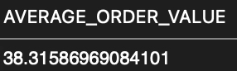

1. Total Pizzas Sold (Sum of quantity)

***INPUT***

SELECT SUM(QUANTITY) AS TOTAL_PIZZA_SOLD

FROM `dominos pizza sales`;

***OUTPUT***

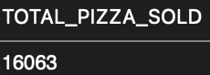

1. Total Orders (Sum of Distinct Order ID’s)

***INPUT***

SELECT COUNT(DISTINCT ORDER_ID) AS TOTAL_NUMBER_OF_ORDERS

FROM `dominos pizza sales`;

***OUTPUT***

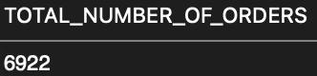

1. Average Pizzas Per Order (Total no. of pizzas sold / Total no. of orders)

***INPUT***

SELECT SUM(QUANTITY)/COUNT(DISTINCT ORDER_ID)AS AVERAGE_PIZZA_PER_ORDER FROM `dominos pizza sales`;

***OUTPUT***

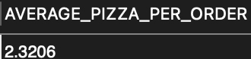

1. **Total Revenue**

Insight: Monitoring total revenue helps track sales performance and identify trends over time. It also helps gauge the effectiveness of marketing strategies and promotions.

1. **Average Order Value (AOV)**

Insight: Understanding AOV helps in assessing customer spending behavior. This metric guides pricing strategies and promotional offers to increase the overall spend per order.

1. **Total Pizzas Sold**

Insight: Tracking the total number of pizzas sold provides insights into product demand and helps in managing inventory effectively. It also highlights the popularity of different pizza categories.

1. **Total Orders**

Insight: The number of total orders indicates customer engagement and business volume. It helps evaluate the success of marketing efforts and customer retention strategies.

1. **Average Pizzas Per Order**

Insight: Analysing the average number of pizzas per order reveals customer purchasing patterns. This information is useful for creating bundle offers and optimizing the menu to meet customer preferences.

**Hourly Trends for Total Orders**

***INPUT***

SELECT ORDER_DATE, COUNT(DISTINCT ORDER_ID) AS TOTAL_ORDERS

FROM `dominos pizza sales`

WHERE ORDER_DATE BETWEEN '2015-01-01' AND '2015-12-31'

GROUP BY ORDER_DATE

ORDER BY ORDER_DATE;

***OUTPUT***

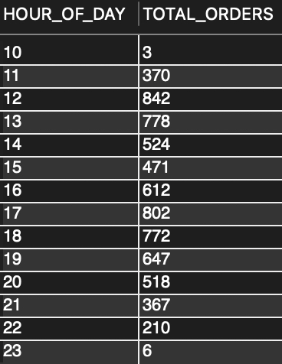

**Day of the Week Trend of Orders**

***INPUT***

SELECT DAYNAME(ORDER_DATE) AS DAY_OF_WEEK, COUNT(DISTINCT ORDER_ID) AS TOTAL_ORDERS

FROM `dominos pizza sales`

WHERE YEAR(ORDER_DATE) = 2015 -- Adjust the year as needed

GROUP BY DAY_OF_WEEK

ORDER BY FIELD(DAY_OF_WEEK, 'Monday', 'Tuesday', 'Wednesday', 'Thursday', 'Friday', 'Saturday', 'Sunday');

***OUTPUT***

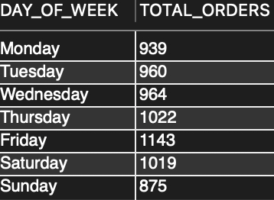

**Percentage of Sales by Pizza Category**

***INPUT***

SELECT PIZZA_CATEGORY, SUM(TOTAL_PRICE) AS TOTAL_SALES

FROM `dominos pizza sales`

GROUP BY PIZZA_CATEGORY;

***OUTPUT***

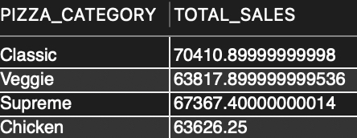

**Percentage of Sales by Pizza Size**

***INPUT***

SELECT PIZZA_SIZE, SUM(TOTAL_PRICE) AS TOTAL_SALES

FROM `dominos pizza sales`

GROUP BY PIZZA_SIZE;

***OUTPUT***

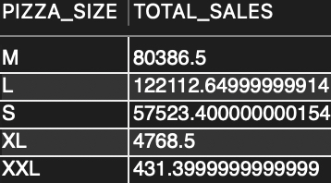

**Top 5 best sellers by Total Pizza sold**

**INPUT**

SELECT PIZZA_NAME, SUM(QUANTITY) AS TOTAL_PIZZAS_SOLD

FROM `dominos pizza sales`

GROUP BY PIZZA_NAME

ORDER BY TOTAL_PIZZAS_SOLD DESC

LIMIT 5;

**OUTPUT**

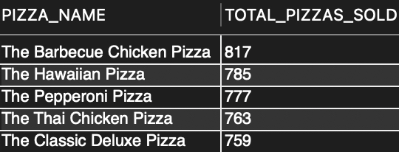

**Bottom 5 worst sellers by total pizza sold**

**INPUT**

SELECT PIZZA_NAME, SUM(QUANTITY) AS TOTAL_PIZZAS_SOLD

FROM `dominos pizza sales`

GROUP BY PIZZA_NAME

ORDER BY TOTAL_PIZZAS_SOLD ASC

LIMIT 5;

**OUTPUT**

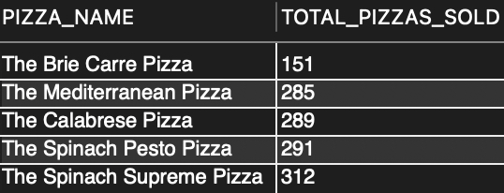

**Top 5 Pizza by Revenue**

**INPUT**

SELECT PIZZA_NAME, SUM(TOTAL_PRICE) AS TOTAL_REVENUE

FROM `dominos pizza sales`

GROUP BY PIZZA_NAME

ORDER BY TOTAL_REVENUE DESC

LIMIT 5;

**OUTPUT**

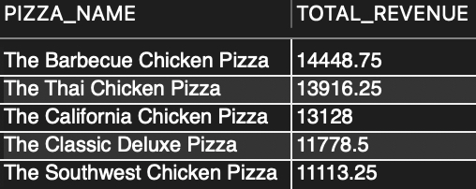

**Bottom 5 Pizza by Revenue**

**INPUT**

SELECT PIZZA_NAME, SUM(TOTAL_PRICE) AS TOTAL_REVENUE

FROM `dominos pizza sales`

GROUP BY PIZZA_NAME

ORDER BY TOTAL_REVENUE ASC

LIMIT 5;

**OUTPUT**

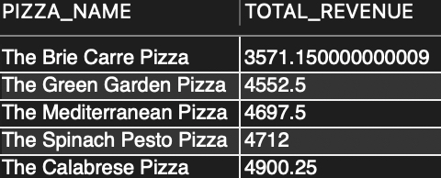

1. **Hourly Trends for Total Orders**

Insight: Identifies peak hours for orders, helping to optimize staffing and resources during busiest times to manage the demand accordingly.

1. **Day of the Week Trends for Total Orders**

Insight: Shows which days have the highest and lowest order volumes, aiding in scheduling and promotional planning in order to satisfy the demand.

1. **Top 5 and Bottom 5 Pizzas by Revenue**

Insight: Highlights the pizzas generating the most and least revenue, guiding inventory and marketing strategies to maximise profit and improve profit margins.

1. **Top 5 and Bottom 5 Pizzas by Total Orders**

Insight: Reveals the most and least popular pizzas, useful for menu adjustments and targeted promotions which eventually leads to bigger orders leading to better margins.

“In conclusion, the analysis of Domino’s pizza sales data for the year **2015** reveals valuable insights into consumer behaviour and revenue trends. Key findings include a total revenue of **Rs** **265222/-** with an average order value of **Rs 38.31/-.** The year saw **16063** pizzas sold across **6922** orders, averaging **2.3** pizzas per order. These insights provide a comprehensive understanding of sales performance and highlight opportunities for strategic growth and market optimization.”

KPI

**Total Revenue of Dominos Pizza Average Ord**